**Demo 6**

**How to Create an Interactive Dashboard with a Combo Box** 

**Steps to be followed:**

**Step 1: Open the Excel file**

* 1. Open the file named **Chart.xlsx** and click on the **Combo box** worksheet

**Step 2: Create an interactive dashboard with Combo Box**

2.1 Create three sets of regions in column R as below:

|  |
| --- |
| North |
| West |
| Middle |

2.2 Under the Developer Tab, choose **Insert** and then **Combo Box**

2.3 Place the **Combo Box** in any white area

2.4 Right-click on the empty Combo Box and choose **Format Control**

2.5 Choose **Input range** and **Cell link** as shown below and click **OK**

2.6 Whenever we change the combo control, the number in Q1 changes

2.7 In column H7, enter the following formula and copy it over to the rest of the H rows

=OFFSET($B$6,ROW()-6,$Q$1)

2.8 The table looks like this after the calculations:

2.9 Choose the data on the table and insert a **2-D Column** chart

2.10 The chart appears on the empty area of the sheet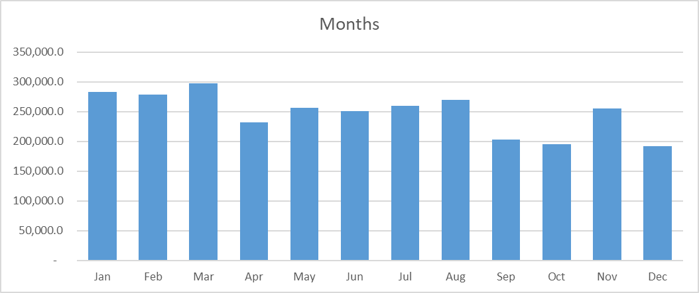

2.11 On changing the values in the Combo Box, the chart changes to the region chosen

